FORMAL DESCRIPTION:

Entities:

Train, Seat_Status, Passenger, Route, Payment, Admin

Attributes of Entities:

**Train :** *Single Valued Attributes:* Train_id, Train_name, Train_type

**Passenger :** *Single Valued Attributes:* SSN, Age, Gender, Phn_num

*Composite Attributes:* ​ Fname, Minit, Lname

**Route :** *Single Value Attributes:* Source, Destination, Arr_time, Dep_time, Fair

**Admin :** *Single Value Attributes:* User_id, Password

**Payment :** *Single Value Attributes:* Payment_id, Mode, Status, Payment_date

**Seat_Status :** *Single Value Attributes:* Date, Status, Seat_no

​

Relationships :

1. Reservation:

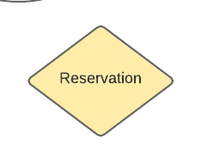

1. Travels:

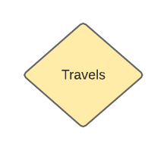

1. Has Seats

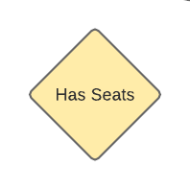

1. Has

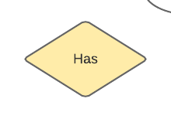

**Total and Partial participation constraints, Mapping cardinalities:**

1. **Many to Many Relationship, One to One Relationsip and One to Many Relationships:**

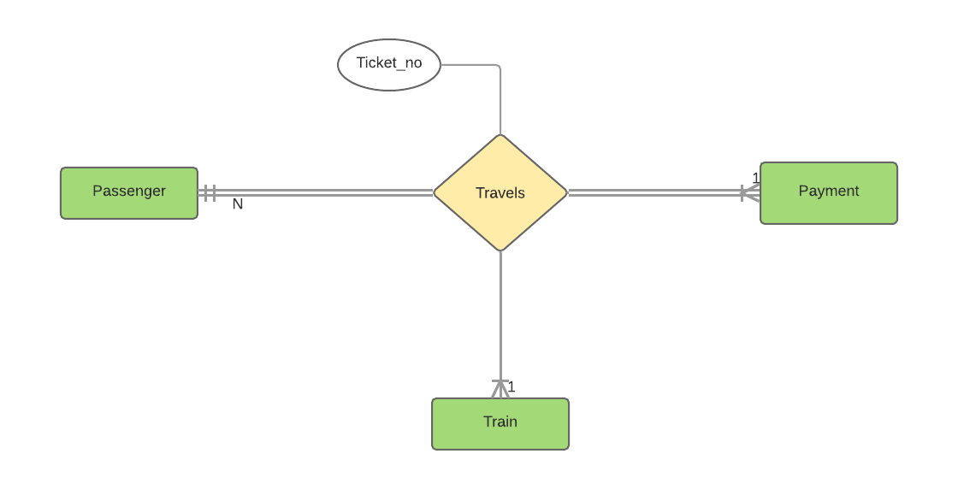

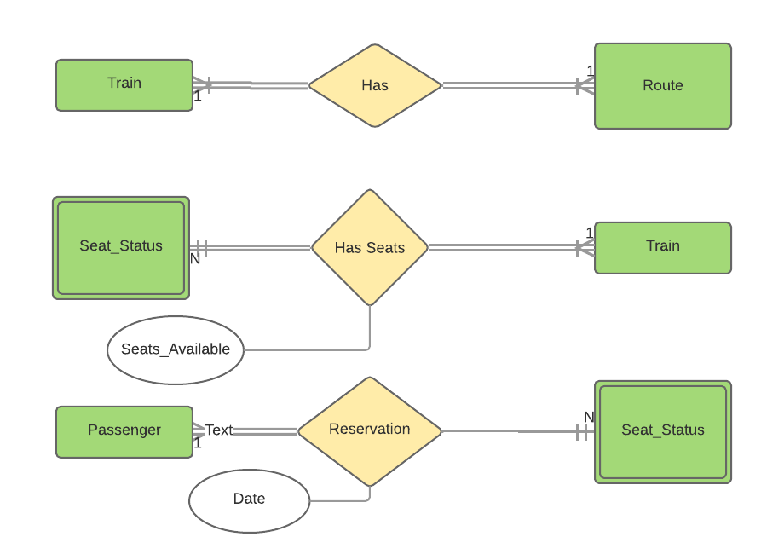

**Mapping ER diagram to Relational Database schema:**

**A. One to Many(1 to N) relationship mapping into tables:**

**1. As per 1 to N mapping we added ‘S_Train_id’ attribute to Seat_Status as a Foreign Key that refers Primary key ‘​Train_id’​ of Train and added attribute Seats_Available of Relation to Seats_Status.**

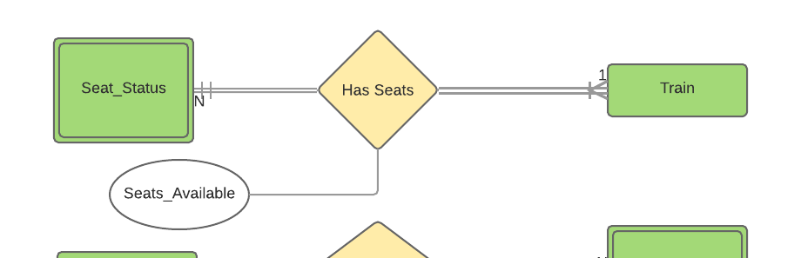

**Seat_Status(Date, Status, Seat_no, S_Train_id, Seats_Available)**

**Train(Train_id, Train_type, Train_name)**

1. **As per 1 to N mapping we added ‘S_SSN’ attribute to Seat_Status as a Foreign Key that refers Primary key ‘​SSN​’ of Passenger.**

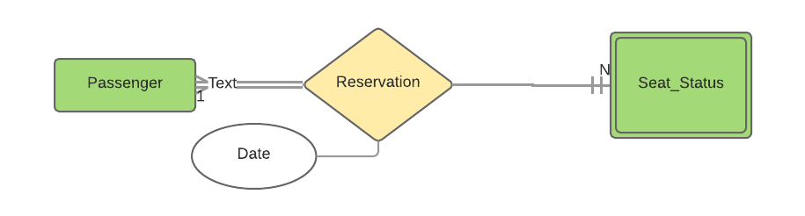

**Seat_Status(Date, Status, Seat_no, S_Train_id, S_SSN, Seats_Available)**

**Passenger(SSN, Fname, Minit, Lname, Gender, Age, Phn_num)**

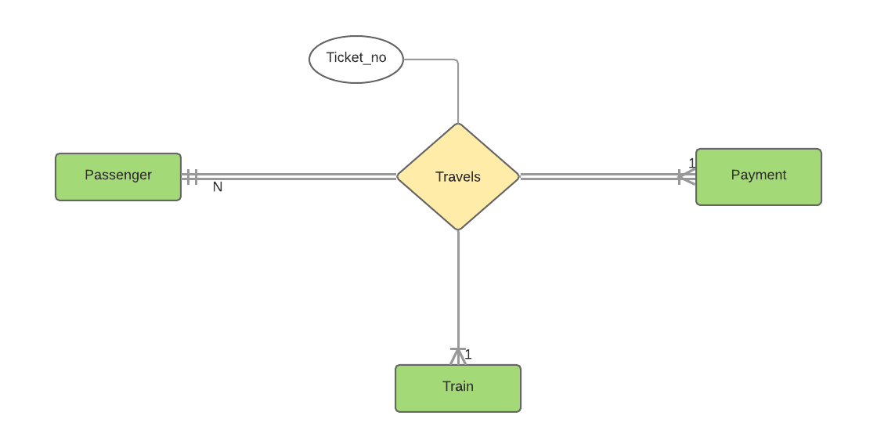

**Consider Passenger to Train**

1. **As per 1 to N mapping we added ‘P_Train_id’ attribute to Passenger as a Foreign Key that refers Primary key ‘Train_id​’ of Train and added attribute Ticket_no added to Passenger.**

**Passenger(SSN, Fname, Minit, Lname, Gender, Age, Phn_num, P_Train_id, Ticket_no)**

**Train(Train_id, Train_type, Train_name)**

**Consider Passenger to Payment**

1. **As per 1 to N mapping we added ‘P_payment_id’ attribute to Passenger as a Foreign Key that refers Primary key ‘​Payment_id’​ of Payment.**

**Passenger(SSN, Fname, Minit, Lname, Gender, Age, Phn_num, P_Train_id, Ticket_no, P_payment_id)**

**Payment(Payment_id, Mode, Status, Payment_date)**

**B. ​One TO One Relationship mapping:**

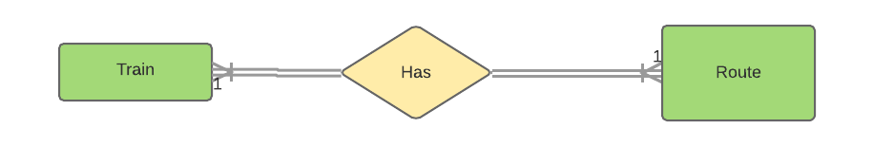

1. **As per 1 to 1 mapping we merged both the Train and Route as one entity and gave Train_id as a primary key.**

**Train_route(Train_id, Train_name, Train_type, Source ,Destination, Arr_time, Dep_time, Fare)**